<>cmeprojects
User manual
For staff: tasks, onboarding, cars, apps and the Assistant
Engaged Care Melbourne · Staff Portal
Version 1.0 · November 2026
Prepared by cmeprojects

Contents

Right-click the list and choose Update field if the page numbers don't show.

Getting started
The Staff Portal is where you see your tasks, finish your onboarding, use the company cars and ask questions. It works on a computer and on your phone.

Signing in
- Open the company website and choose Sign in (or open the portal link from your welcome email).
- Enter your email and password, or ask for a sign-in link.
- If asked, enter the 6-digit code from your authenticator app.
Good to know
Five wrong passwords lock your account for 15 minutes. You can still sign in with a sign-in link.

The website and Assistant
The Assistant answers questions from the company's own documents. Signed-in staff also get answers from staff-only policies.
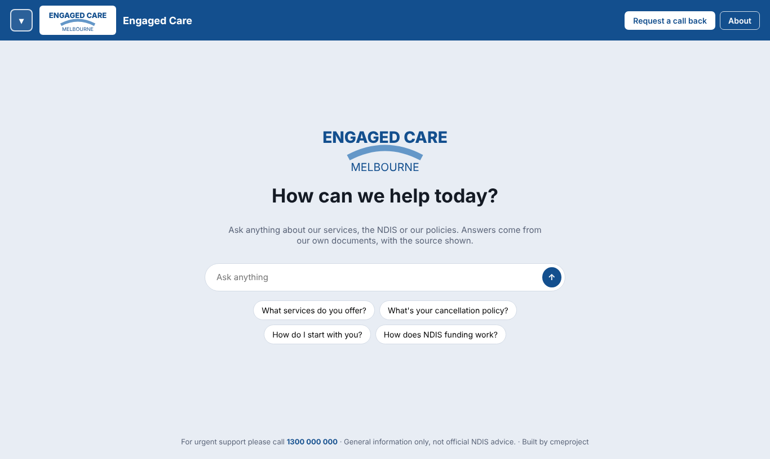
The website: ask anything, or tap a suggested question.
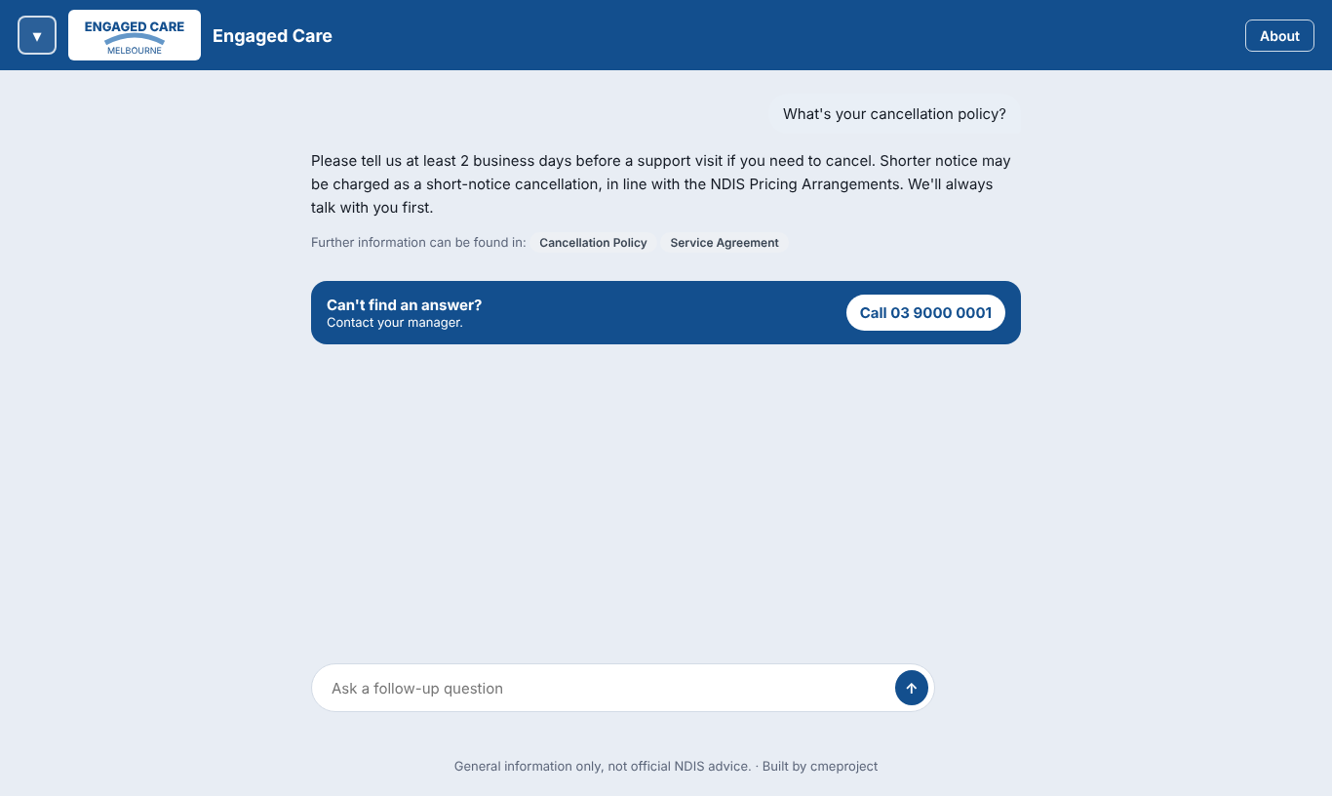
Signed in: answers show where to read more, and Contact your manager if it can't help.

Raise a question
- Open the options panel with the button at the top left.
- Choose Raise a question, fill in your question and who should answer, then Send question.
- Follow the answer in the portal: My tasks → My requests and questions.
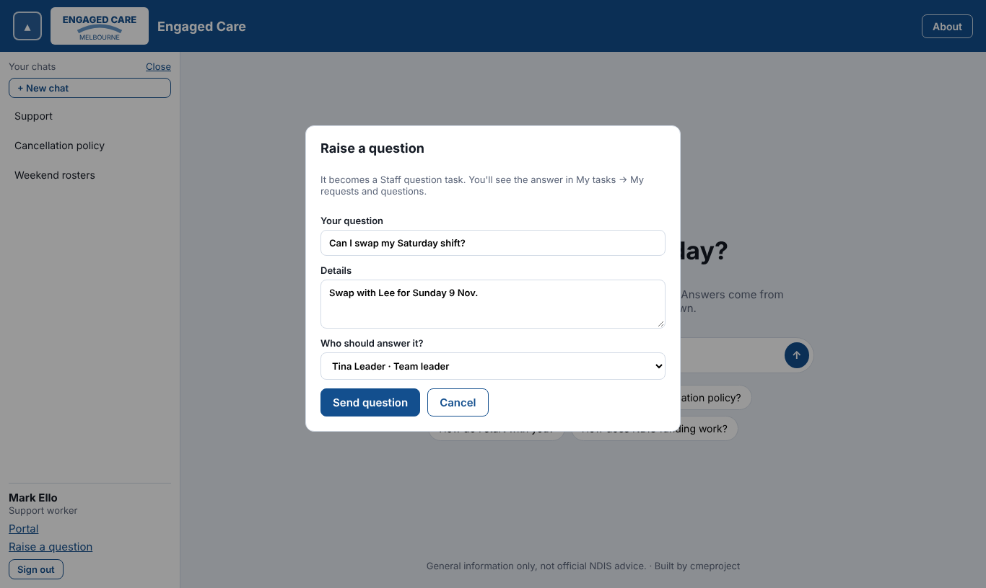
Raise a question from the website.

Your tasks
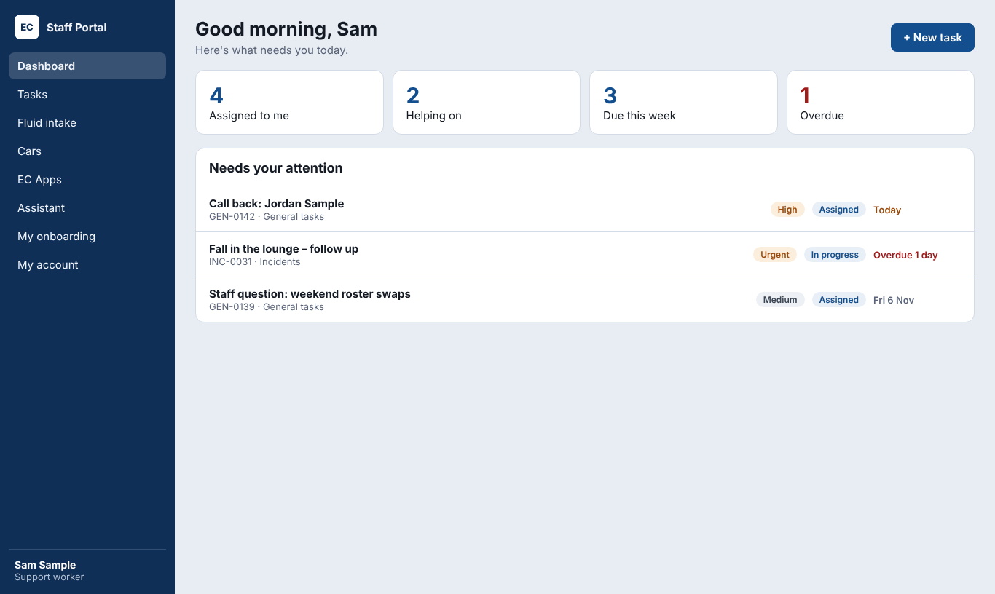
Your dashboard: what needs you today.

My tasks
Tabs show tasks assigned to you, tasks you're helping on, your own requests and questions, and completed ones. Hover over a task to see a quick snapshot.
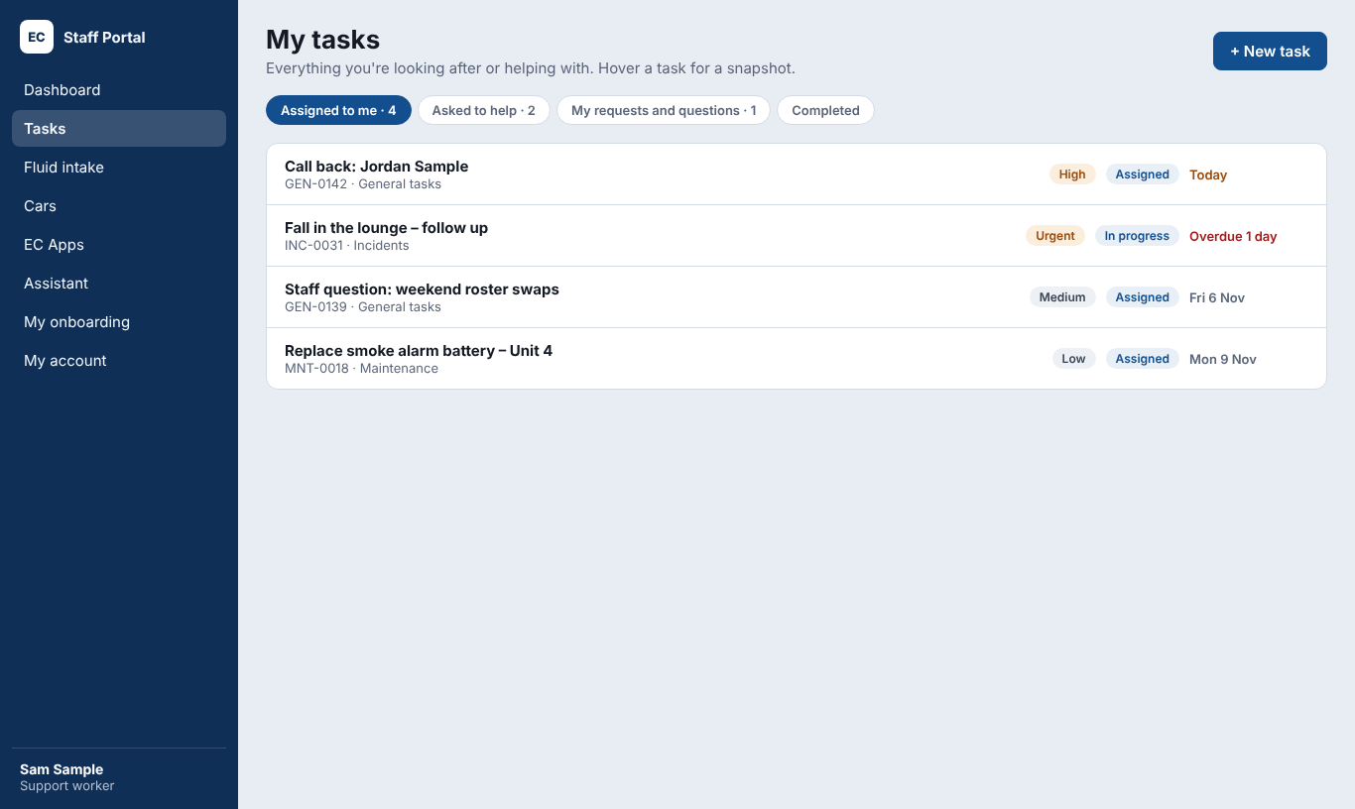
My tasks.

Following your questions
Open a question in place to see who has it and the latest updates. Use Follow up to add a note, or Escalate to send it to your team leader or the managers.
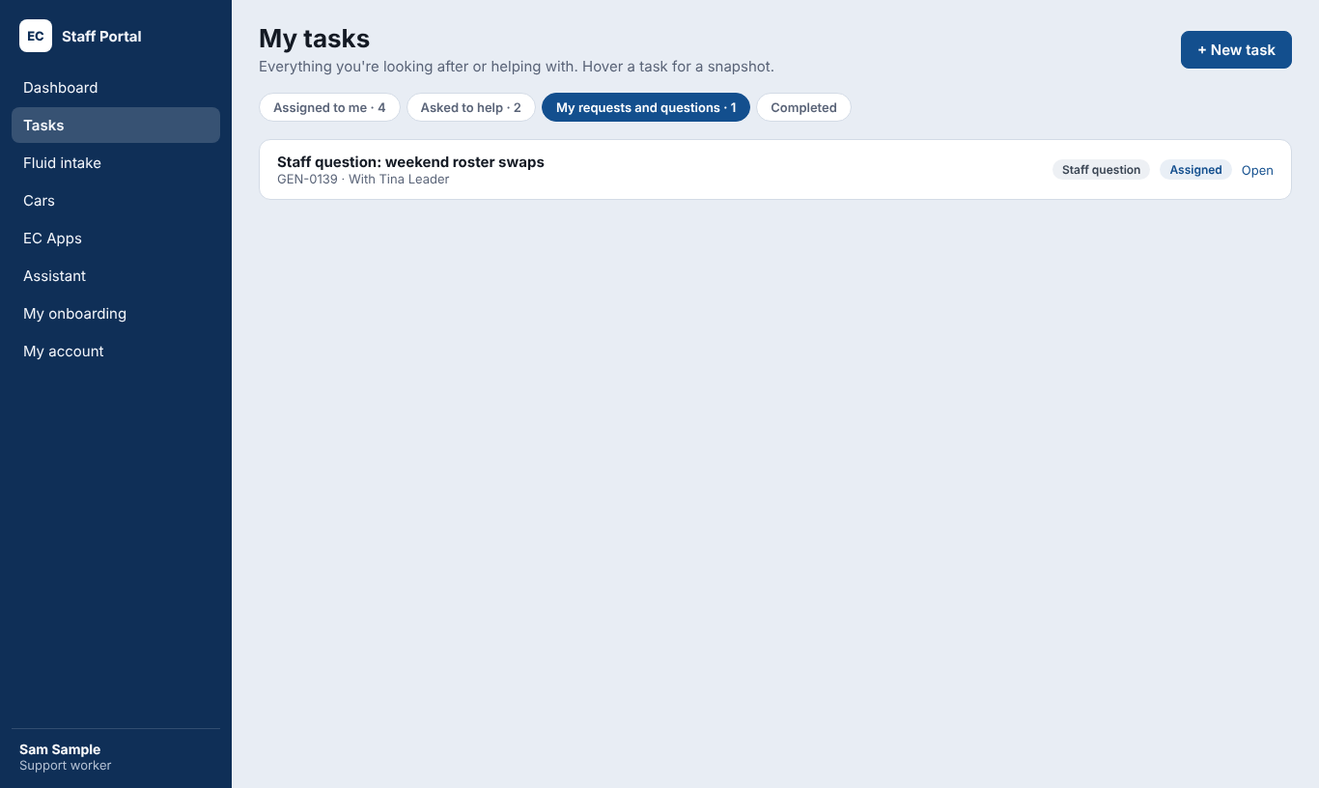
My requests and questions.

Raising a task or question
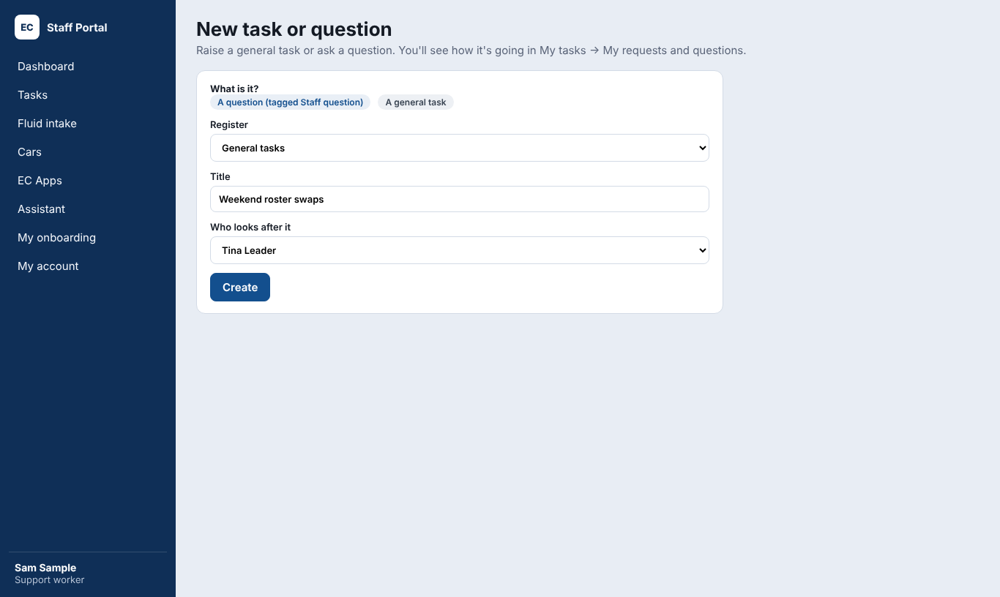
New task or question (support workers).

My onboarding
Everything you need to read, complete and upload, plus forms sent to you. Your progress saves as you go.
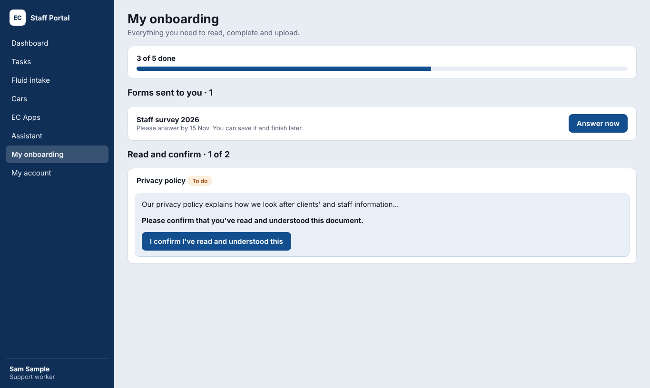
My onboarding.
- Read and confirm: open the document, then press I confirm I've read and understood this.
- Uploads: add your certificate and its expiry date. A staff admin checks it.
- Forms: press Answer now. You can save and finish later.

Cars and the phone apps
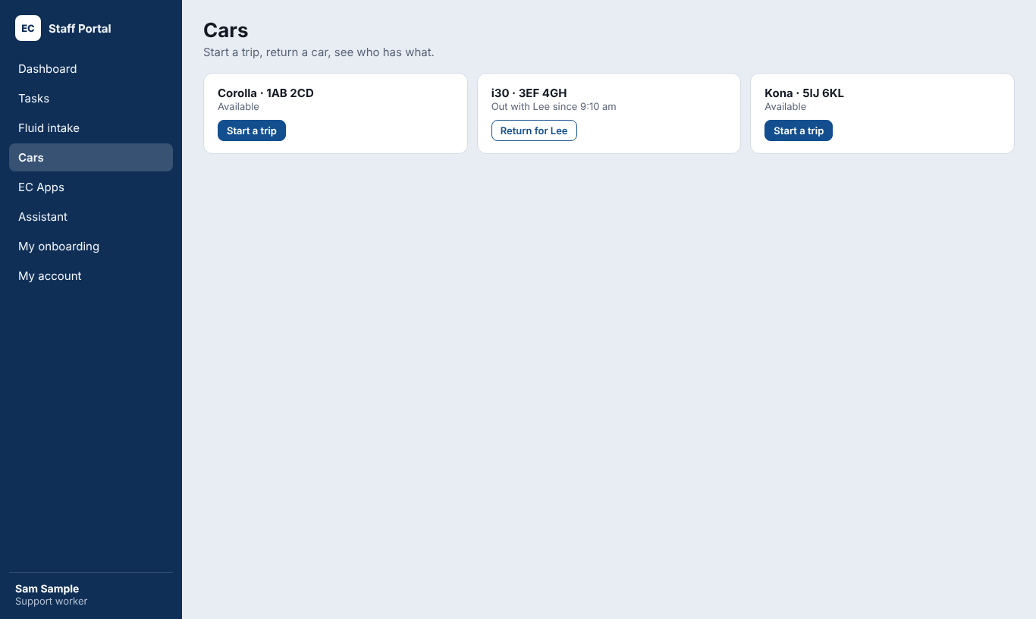
Cars: start a trip or return a car.

Put the app on your phone
- In the portal, open EC Apps and scan the QR code with your phone camera.
- Choose Share → Add to Home Screen (iPhone) or the menu → Install app (Android).
- Open it, sign in once, then choose a 4-digit PIN.
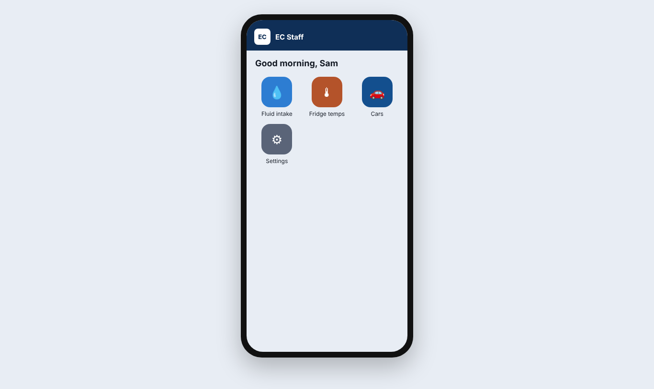
The Staff app on a phone.
Your PIN
The app asks for your PIN each time you open it, and after a minute away. Five wrong PINs mean signing in again.

